Herrera, Mark Daniel L.
BSIT 2-F1
EXERCISE 4.

- Select * From employee_data where salary >= 90000 AND title NOT LIKE “%programmer%”;
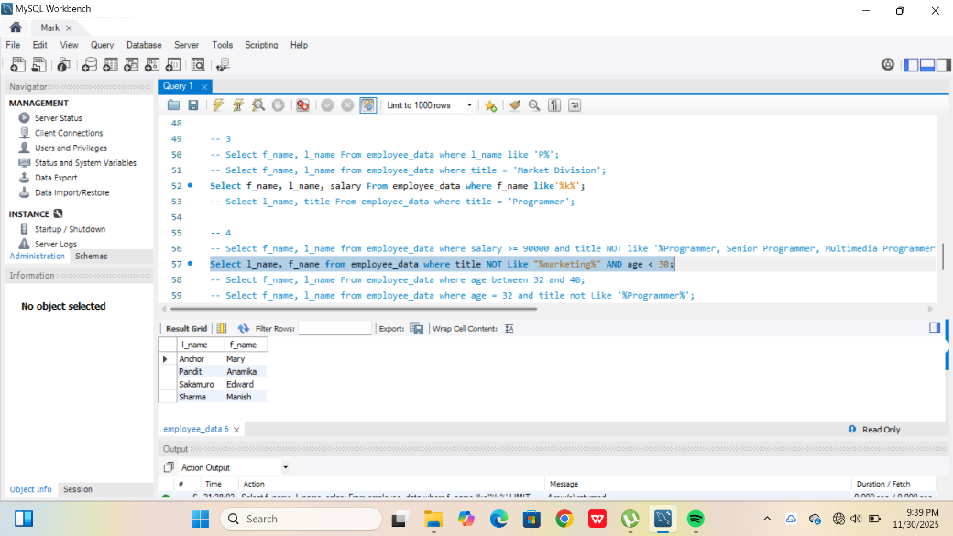

- Select id, f_name, l_name From employee_data where age BETWEEN 32 and 40
- Select f_name, l_name From employee_data where age = 32 AND tite NOT LIKE “%programmer%”

